During the MSI install you input comment separated values (csv) such as D1,D2,D3 to specify three device. 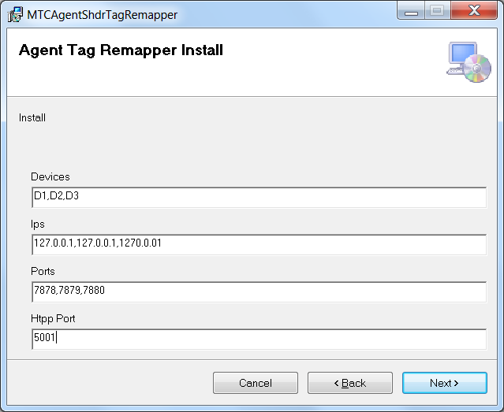

It automatically generates an agent.cfg file and THIS MSI generates an generic Mazak Devices.xml file (for each device too) and installation time.

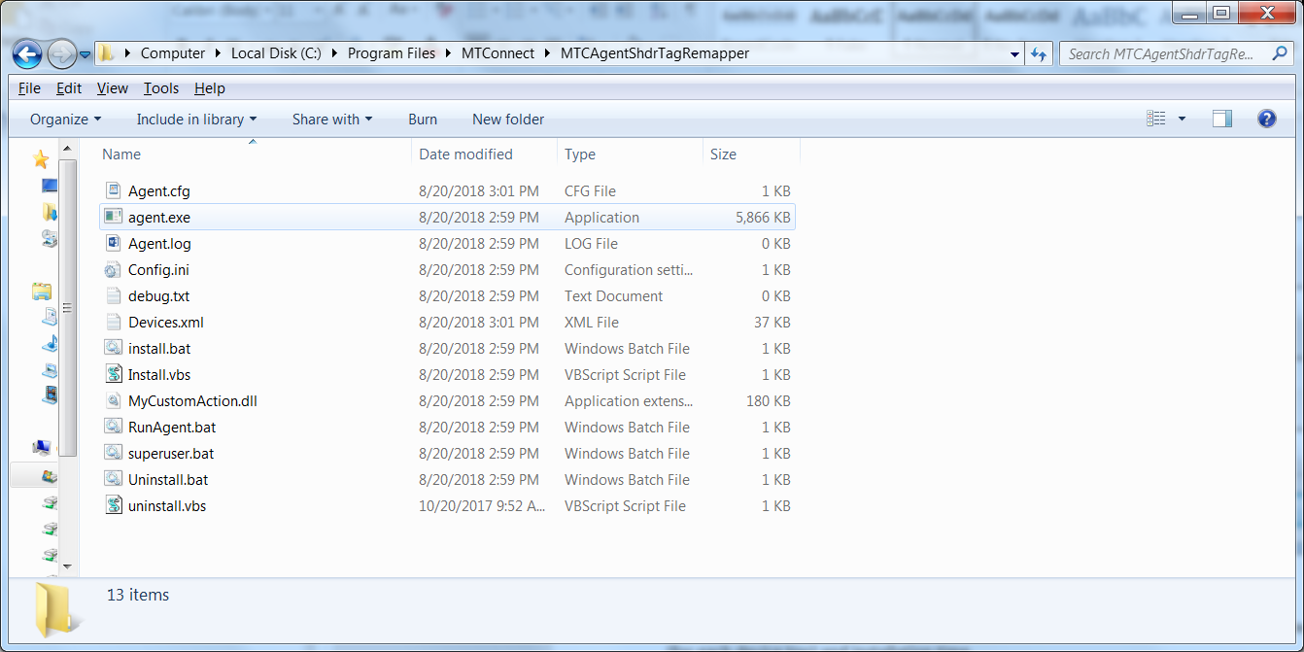The D1,D2,D3 are put into the Agent.cfg file:

Devices = Devices.xml

ServiceName = MTConnectAgent

Port = 5001

CheckpointFrequency=10000

AllowPut=true

Adapters

{

**D1**

**{**

**Host = 127.0.0.1**

**Port = 7878**

**}**

**D2**

**{**

**Host = 127.0.0.1**

**Port = 7879**

**}**

**D3**

**{**

**Host = 1270.0.01**

**Port = 7880**

**}**

}

# Logger Configuration

logger_config

{

logging_level = fatal

output = cout

}

And the devices.xml file is installed by creating D1, D2, D3 devices:

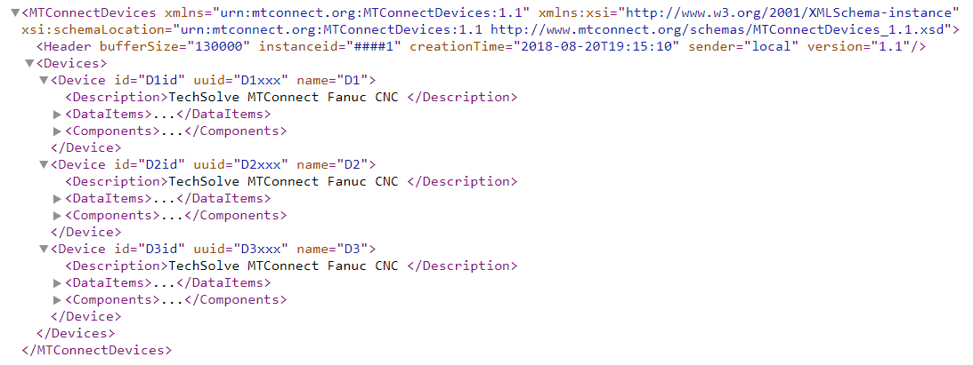

Renames have changed. Here is the latest mapping:

[TAGRENAMES]

# Revision 8 2018 for TechSolve Agent

X_actual=Xabs

Y_actual=Yabs

Z_actual=Zabs

# p1 is controller 1!!

P1S1_speed_act=Srpm

p1_execution=execution

p1_program=program

p1_feedrate_override=path_feedrateovr

p1_feedrate_act=path_feedratefrt

p1_spindle_override=Sovr

p1_program=program

p1_mode=controllermode

[ENUMREMAPPING]

p1_execution.READY=IDLE

p1_execution.ACTIVE=EXECUTING

p1_execution.INTERRUPTED=PAUSED

p1_execution.STOPPED=PAUSED